**JAVASCRIPT SOURCE.**

1. Start the challenge.
2. Right- click.
3. Inspect the Element.

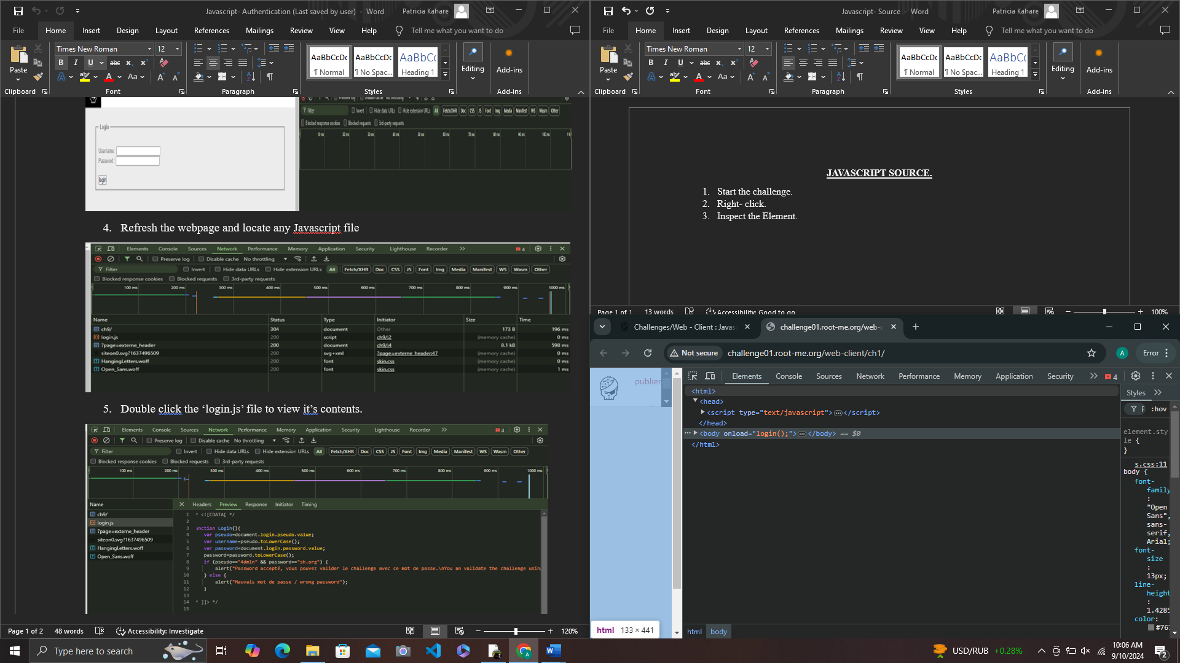

1. Locate the in-line script.

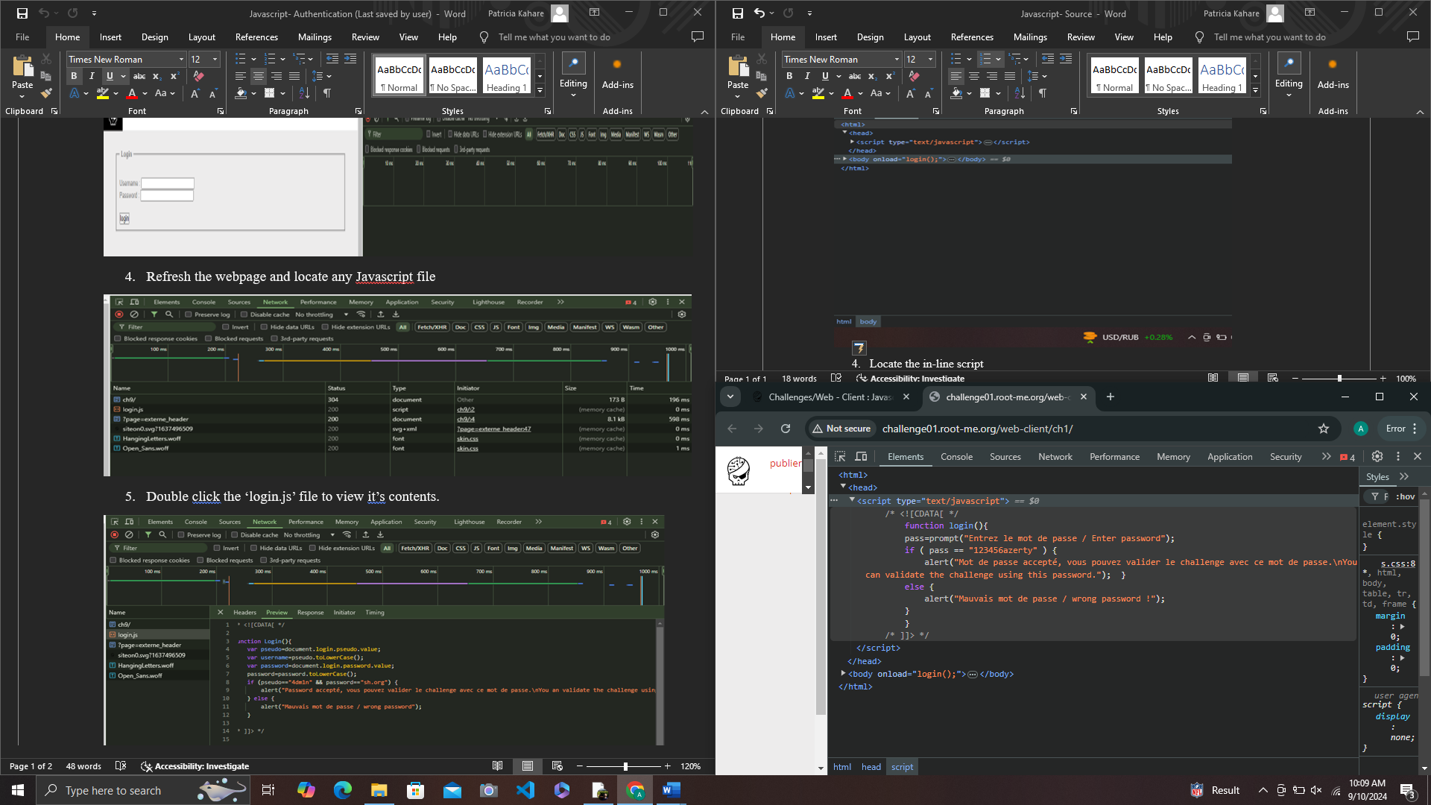

1. Locate the password within the scriptand input it within the prompt .



Password: 123456azerty